Bill of Materials

* 1 raspberry pi
* 1 gpio breakout board
* 1 SunFounder Switch Hall Sensor Module for Arduino and Raspberry Pi
* 1 (1x3-Pin anti-reverse cable)
* 3 jumper cables

Circuit Diagram

* Provided by SunFounder

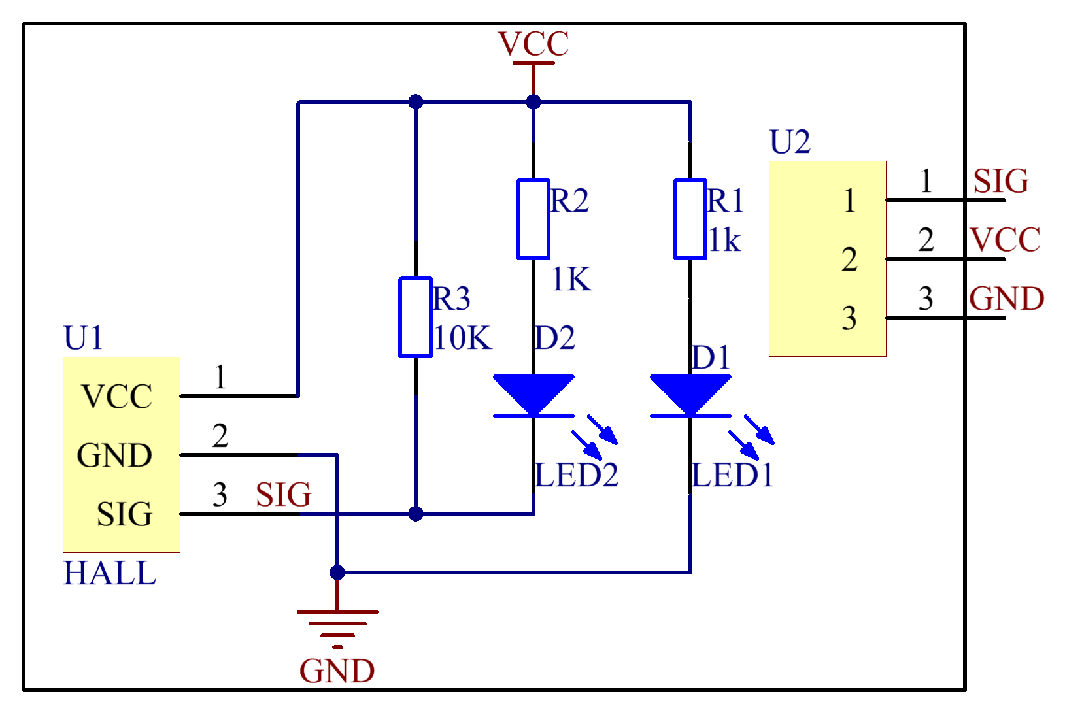

Layout diagram

* Note diagram is for a normal hall effect sensor without led integrated circuit.

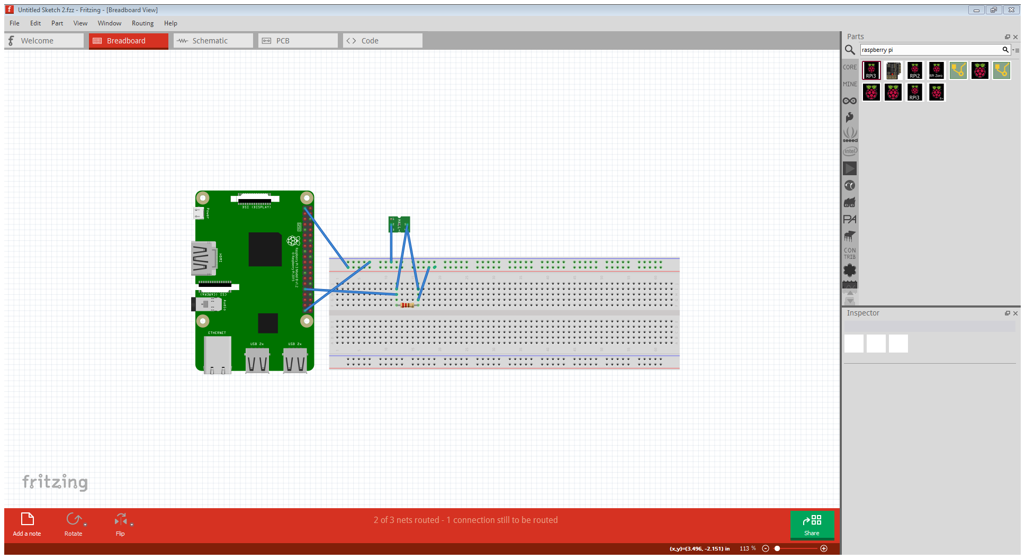

GitHub Repository link

https://github.com/Growlith3/AutoCar-Comparison-Algorithm